1. **Release Information**

* Github: <https://github.com/AlexWu1024/aha-auto-test>
* Version: v1.0.1
* Description: 1st release

1. **User Guide**
   * **Set up**
     1. Install Docker
        + Download:

<https://www.docker.com/get-started/>

* + - * Ubuntu follow this page:

<https://docs.docker.com/engine/install/ubuntu/>

* + 1. Apply Slack and SendGrid API
       - Slack API:

<https://api.slack.com/>

* + - * Slack API set up follow this page:

<https://www.datacamp.com/tutorial/how-to-send-slack-messages-with-python>

* + - * SendGrid API:

<https://sendgrid.com/en-us/solutions/email-api>

* + 1. Edit Config File
       - Config file: "config/UI_TEST_setting_config.yaml"
       - Fill in the API token and parameters into the config.

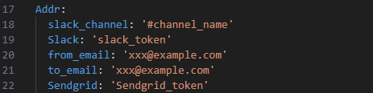

* + - * Fill in the email and password into the config.

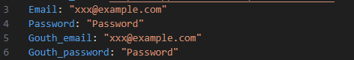

* + **Run APP**
    1. Build Docker Images
       - $ docker build -t auto-test .
    2. Run Docker Container
       - $ docker run -it --cpuset-cpus=[cpu number] -v [local path]:/app/log auto-test

Example:

* + - * $ docker run -it --cpuset-cpus="0-4" -v ./log:/app/log auto-test

1. **Output**
   * **Test result summary**

** The total run time is less than the sum of the individual test times due to parallelized testing.

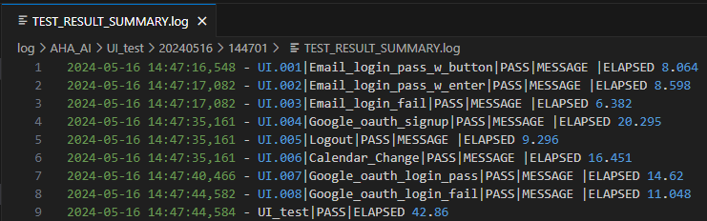

* + **Total execution log**

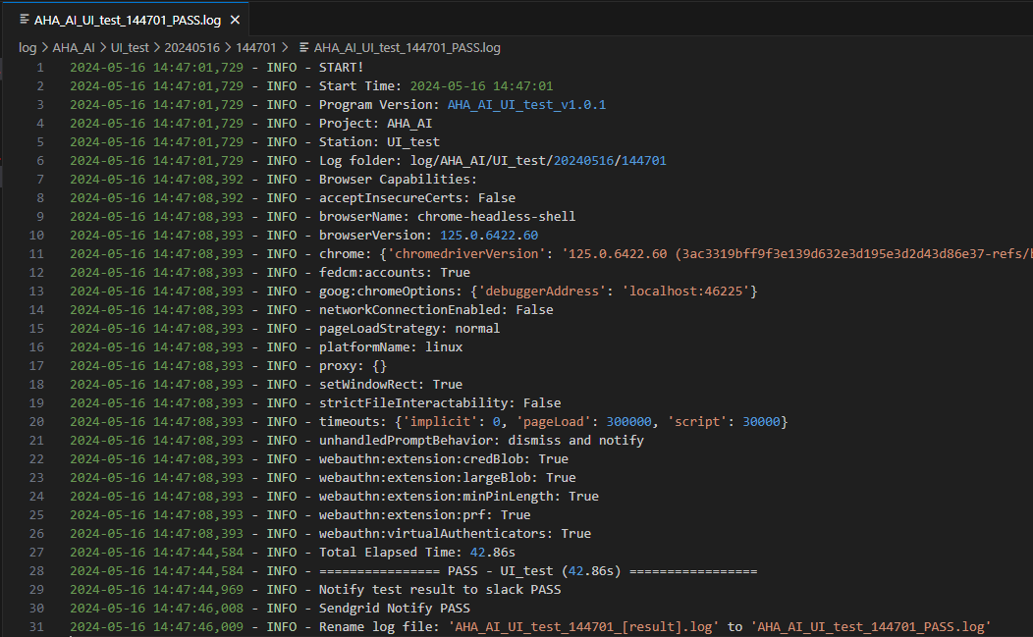

* + **Execution log of each test case**

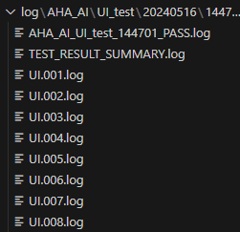

* + **Slack** **notification**

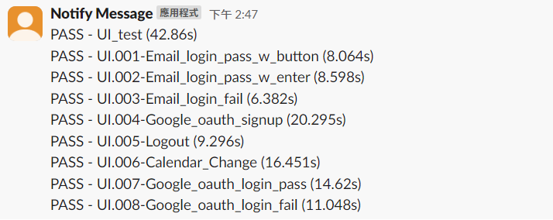

* + **Email notification**

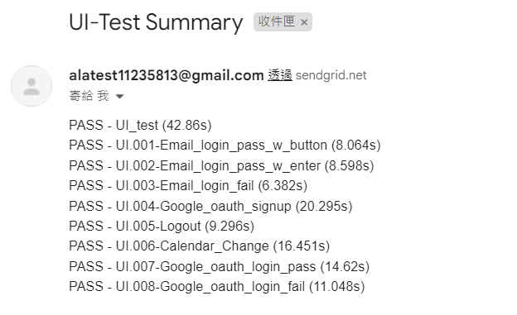

1. **Test Case Description**
   * **UI.001-Email_login_pass_w_button**

Sign in to an existing Aha account using email by clicking "Continue" button.

* + **UI.002-Email_login_pass_w_enter**

Sign in to an existing Aha account using email by pressing the 'Enter' key.

* + **UI.003-Email_login_fail**

Login failure test with incorrect password using email.

* + **UI.004-Google_oauth_signup**

Sign up a new Aha account using Google OAuth.

* + **UI.005-Logout**

Sign out Aha account.

* + **UI.006-Calendar_Change**

Edit profile of signed in account and change the date of the calendar.

* + **UI.007-Google_oauth_login_pass**

Sign in to an existing Aha account using Google OAuth.

* + **UI.008-Google_oauth_login_fail**

Login failure test with incorrect password using Google OAuth.

1. **Other**
   * **Parallelized testing and one by one testing**

By modifying the CMD in the Dockerfile, parallel testing or one by one testing can be controlled.

